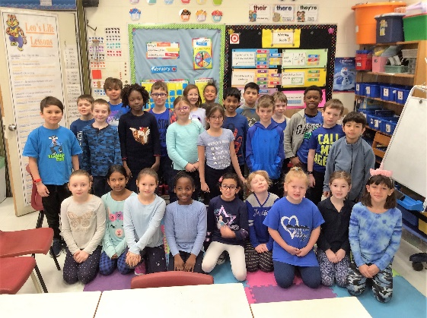

April 6-10

Consider 20 minutes per activity. (Reading, Writing, Math = 1 hour per day)

**Math**

**Math**

**Math**

**Math**

**Math**

**Literacy**

**Literacy**

**Literacy**

**Literacy**

**Distance Learning -** 3 Taggart

**Friday**

**Thursday**

**Wednesday**

**Tuesday**

**Reading** Raz Kids website Read/Answer comprehension questions.

**Writing** Fiction Creative Writing Use your ideas from Thursday and write your story. As you are writing, make sure you include capitals, punctuation and interesting language.

**Subtraction** Warm up: Time yourself for one minute. How many flashcards can you answer correctly? Did you beat yesterday’s time?

Game – Play against someone. Flip a flashcard up so the subtraction sentence is showing. The first person to get the answer gets a point. Go to 10 points. If time – rematch!

**Reading** Raz Kids website Read/Answer comprehension questions.

**Writing** Fiction organize thoughts Choose your characters *(people, animals, aliens,…),* setting *(where the story takes place, day of the week, season,…),* problem *(what needs to be overcome), and* solution *(how they will overcome the problem).*

**Subtraction** Warm up: Time yourself for one minute. How many flashcards can you answer correctly? Did you beat yesterday’s time?

Put your flashcards face down so the answers are showing. What could the subtraction sentence be? T It could be: 10-7 10-7 9-6 8-5 7-4 6-3 5-2 4-1 3-0

**Reading** Raz Kids website Read/Answer comprehension questions.

**Writing** Use the writing you started on Monday. Edit your work for capital letters, punctuation, and proper spelling of No Excuse Words.

**Subtraction** Warm up: Time yourself for one minute. How many flashcards can you answer correctly?

Game – Each player takes a pile of flashcards. Each player flips over one card so the subtraction sentence is showing. The person with the smallest answer wins both cards. 9-7=2 8-3=5 2 wins If the answers are the same, the cards stay and the winner of the next round gets them too. The person with the most cards wins!

**Reading** Raz Kids website Read/Answer comprehension questions.

**Writing** Use the writing you did Monday and make it amazing. Add lots of description and at least 3 Million Dollar Words.

**Subtraction** On the back of the flashcards you made Monday print the answers to the subtraction sentences. Have an adult check your answers or use a calculator to check the answers.

Front:

Back:

**Literacy**

**Monday**

**Fresh air and physical activity**  in **Science:** Go for a family nature walk. What living creatures do you see? Can you find their habitats?

**Creativity** should be encouraged. Is there something that you are interested in learning or love to do? **Art:** Easter is next weekend. Try: ***You Tube – Art for Kids Hub - How to Draw An Easter Bunny Folding Surprise***. We’ve tried these step by step drawings before in class and they are a hit!  **Let your imagination guide you! Mrs. Taggart**

**Reading** Raz Kids website Read/Answer comprehension questions.

**Writing** Non-Fiction Retell

Since I last saw you, what has been your favorite activity that you have done?

**Subtraction/Art** Make subtraction flashcards, cut the cards about the same size. On one side print subtraction sentences up to 10-10=____. Do not write the answer/difference! Leave the back of the card empty for now. For a challenge make cards up to 20-20=____. example:

3

8 – 3 = ___

5

For Fun:

**In your spare time…**

8 – 3 =___

10- 10=___

